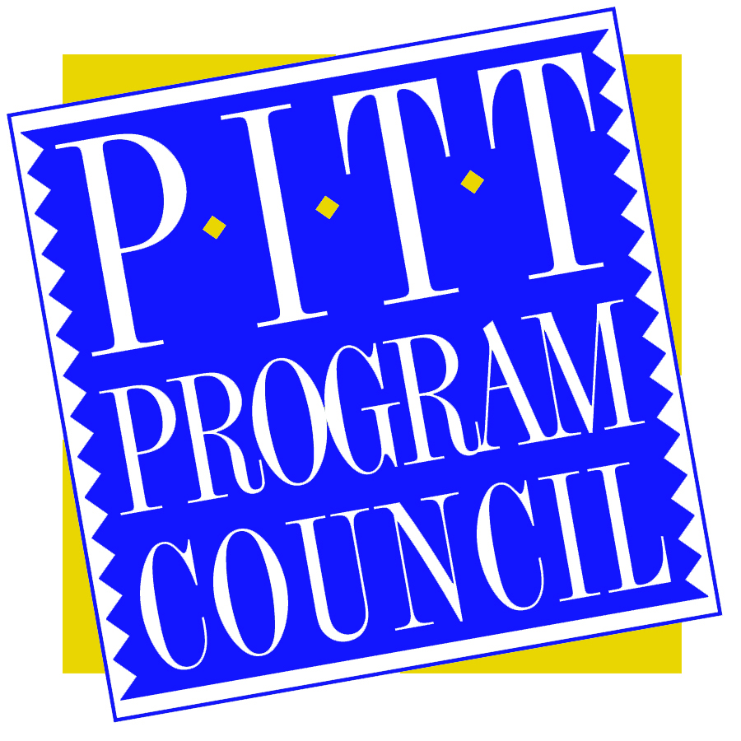

Dear Applicant,

Thank you for your interest in the Pitt Program Council Endowed Book Fund. The fund was created in April 2000, by the Pitt Program Council Executive Board, who wanted to give something back to their fellow students. With the help of the Pitt Telefund, we were able to gain the support of parents of current students, alumni, and more staff and faculty. The most generous donation was made by Mr. Pat Croce, the former President of the Philadelphia 76ers, who matched our goal of $10,000.

Pitt Program Council Endowed Book Fund applicants MUST meet the following qualifications:
- You MUST be an undergraduate student.
- You MUST have a minimum of a 2.75 QPA.
- You MUST be currently enrolled at the Pittsburgh campus with a minimum of 27 credits completed from the Pitt system at the time of application.
- You MUST attend the Oakland campus during the term for which you are applying. You may not apply with plans to study abroad.

Applications MUST include:
- Your current resume that includes extracurricular/work experience and activities where leadership potential can be assessed.
- Your completed Application Form.
- Your completed Question Form.
- Either a transcript or printout from Peoplesoft of your QPA

All parts of the application must be typed. Failure to meet any of these requirements will result in an ineligible application.

This award is intended for students who have been active outside of academic life, and have made a contribution to our campus community. These students may not qualify for financial aid, but are in need of assistance. As a result, an applicant’s financial standing will be discussed in addition to his or hers involvement in campus life.

Your completed application is due by 5pm on Friday, November 20th, 2015. Completed applications may be submitted to M-30 William Pitt Union, or they may be submitted electronically via email. Completed applications should be emailed to ppc@pitt.edu. Make sure the subject of the email reads: (Last Name, First Name) – Book Fund Application. A committee comprised of representatives from The Office of Admissions and Financial Aid, The Office of Student Life, Institutional Advancement, and the Pitt Program Council will review all applications. Incomplete applications will be deemed ineligible.

Sincerely,

Iris Matijevic
Executive Board Director
Pitt Program Council

